作业3（2022年7月13日）

19200300004 黄铭瑞

# 作业内容

1.找棋子

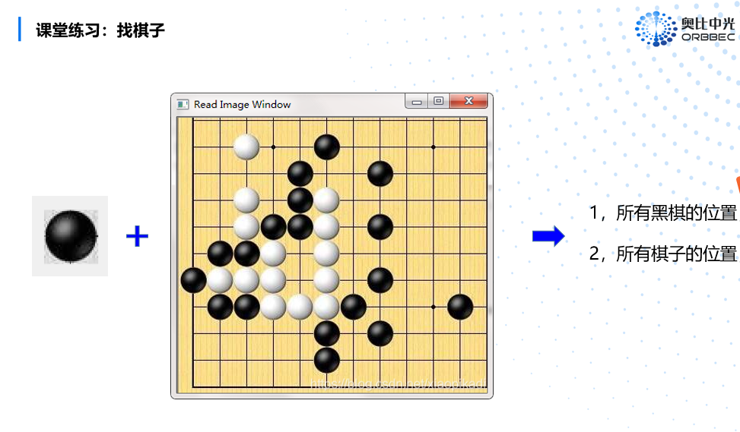

2. 完成RANSAC直线检测与圆检测；

# 作答

1. 首先读取图像的灰度图，再获取黑白两棋的模板，经过两个for循环，确定出当前循环的窗口坐标，该窗口的值和模板的值相减取绝对值，元素求和并赋给输出图像。

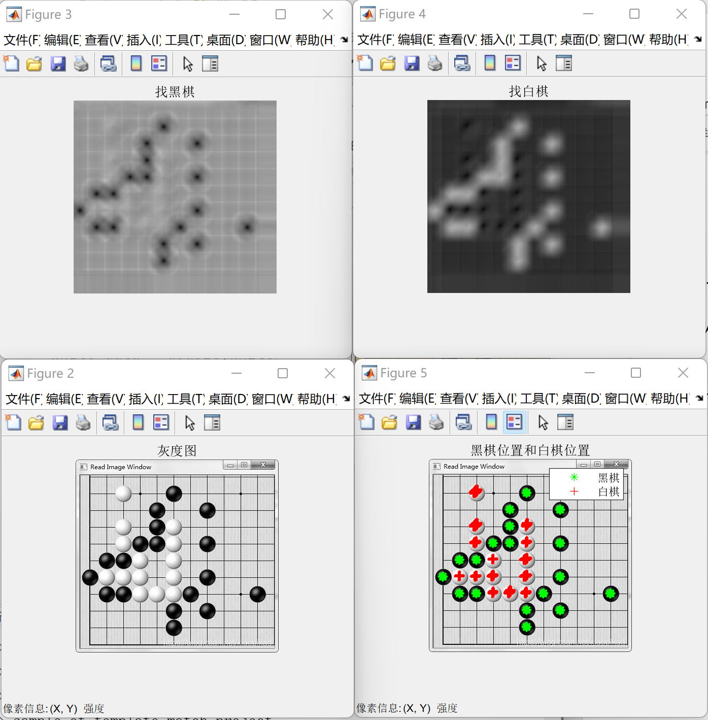

2.

基本思路如下，首先生成80个随机散点，然后再添加20个沿圆分布的散点。尝试1000次，每次随机选取3个点，根据这三个点拟合出圆，并计算出圆心和半径。计算各个点到圆心的距离，如果和半径的差值小于容差值，添加到选择点中。1000次尝试后，选出选择点最多的那一次，绘制出那一次的选择点和根据那一次的圆心和半径拟合圆。拟合方法为最小二乘法。

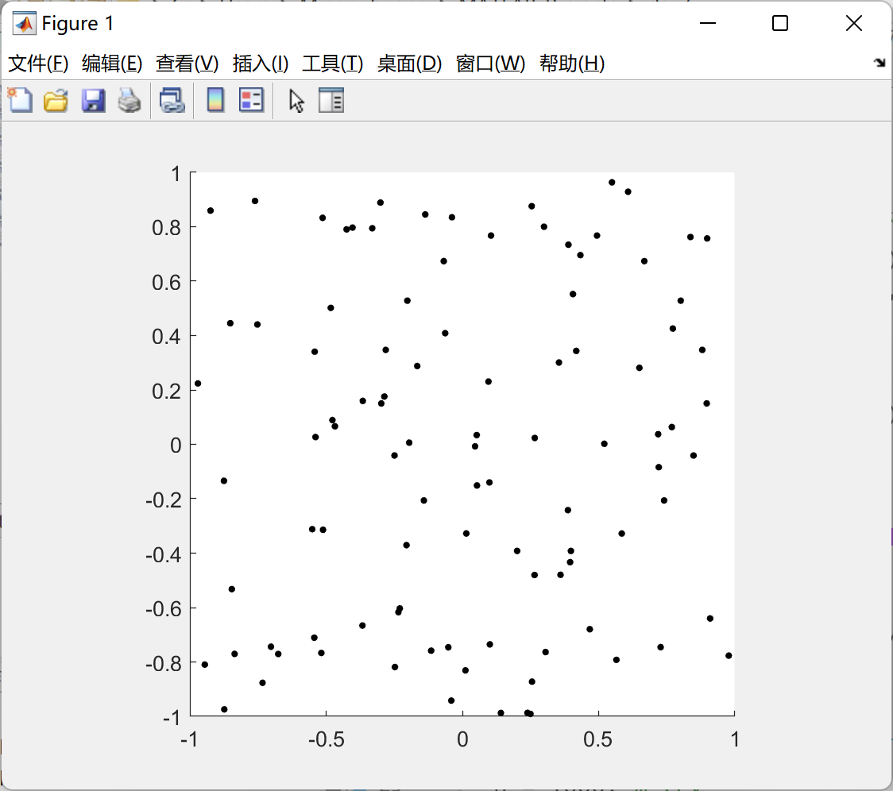

（散点图）

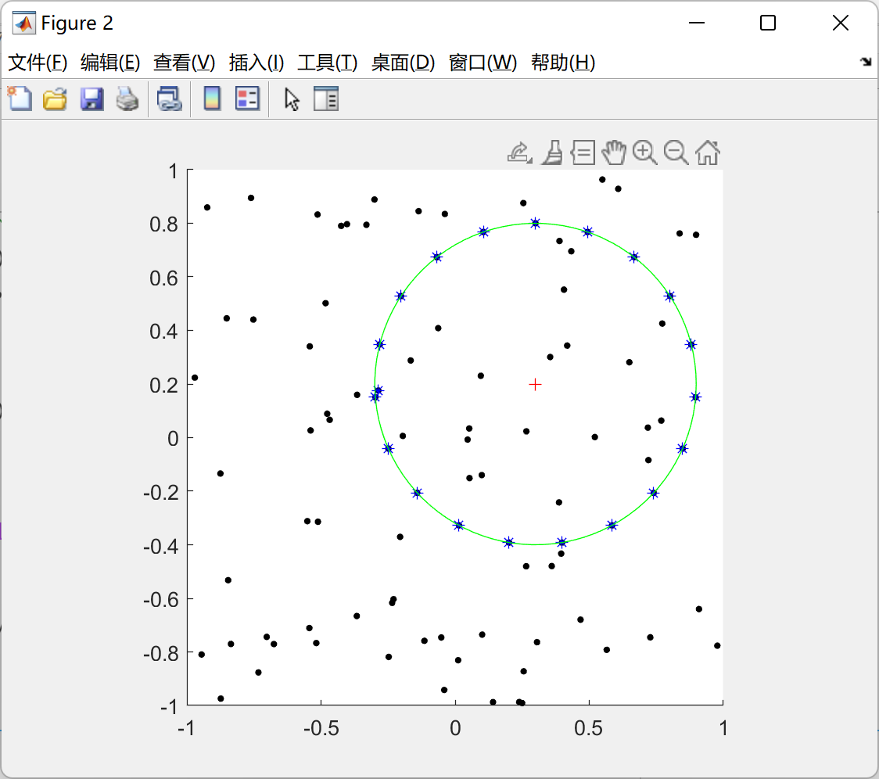

（拟合图）

# 附录

## 模板匹配代码

clear all;

close all;

I= imread('../images/go.png');

imshow(I);

impixelinfo;

img=rgb2gray(I);

black = img(250:283,343:376);

white = img(50:83, 78:111);

[m,n] = size(img);

img_out1=uint8(zeros(m, n)); % 结果矩阵初始化

img_out2=uint8(zeros(m, n));

img_data = double(img); % 数据类型转换

black_data = double(black); % 数据类型转换

white_data = double(white);

for j= 1: m-34+1

for i= 1: n-34+1

%找黑棋

window_data = img_data(j:j+34-1,i:i+34-1);% 确定 img_data 在当前循环对应的窗口坐标；

black_abs_data = abs(window_data-black_data); % 提取出 window_data窗口 与 black_data 相减，取绝对值，；

img_out1(j:j+33,i:i+33) = sum(black_abs_data(:))/1000; % 把所有元素相加求sum, 并赋值给 img_out 的相应格子。

%找白棋

white_abs_data = abs(window_data-white_data);

img_out2(j:j+33,i:i+33) = sum(white_abs_data(:))/1000;

end

end

figure;

imshow(img);

impixelinfo;

title('灰度图');

figure;

imshow(img_out1);

title('找黑棋')

figure;

imshow(img_out2);

title('找白棋')

figure;

imshow(img);

hold on;

impixelinfo;

[r,c] = find(img_out1 < 40);

plot(c+15, r+15, 'g*');

[r,c] = find(img_out2 < 30);

plot(c+15, r+15, 'r+');

title('黑棋位置和白棋位置');

legend('黑棋','白棋');

## RANSAC直线检测代码

clear

close all

clc

%% 生成60个随机点，然后添加11个点的直线，打乱点的顺序

Points = rand(60,2);

line = 0:0.1:1;

y = -0.5 * line + 0.8 + (rand(1,11)-0.5)/50; % try

Points = [Points; cat(1, line, y)'];

scatter(Points(:,1), Points(:,2), 10, 'k', 'filled');

hold on

grid on

daspect([1 1 1]);

Points(:,3) = rand(size(Points,1), 1);

Points = sortrows(Points, 3);

X = Points(:, 1);

Y = Points(:, 2);

%% 尝试1000次

n = 1000; % try

tol = 0.02; % 容差值

for i = 1 : n

choose = randperm(length(X)); % 所有样本点随机排序

choose = choose(1:2); % 随机选取2个样本点

choose_x = X(choose);

choose_y = Y(choose);

% 1，根据这2个样本点，生成直线方程（待完成）。。。

t = polyfit(choose_x, choose_y, 1);

% 2，根据容差值tol，结合直线方程生成容差带，并统计落在容差带内的点的个数（待完成）。。。

all_distance = abs(t(1)*X-Y+t(2))/sqrt(t(1)^2+(-1)^2);

choose = all_distance < tol;

find_t(i,:) = t;

choose_num(i) = sum(choose);

choose_point{i} = choose;

end

%%3，迭代结束后，找出有效样本点数最多的容差带，并显示输出其对应的有效样本点，以及对应的直线（待完成）。。。

[m,index] = max(choose_num);

t = find_t(index, :);

choose = choose_point{index};

choose_x = X(choose);

choose_y = Y(choose);

plot(choose_x, choose_y, 'b*', choose_x, polyval(t,choose_x), 'r-');

legend('所有点', '内点', '最终拟合直线')

hold on

grid on

daspect([1 1 1]);

## RANSAC圆检测代码

clear

close all

clc

%% 生成80个随机点，然后添加20个点圆

Points = 2*(rand(80,2) - 0.5);

scatter(Points(:,1),Points(:,2), 10, 'ko', 'filled');

hold on;

daspect([1 1 1]);

theta = linspace(0, 2*pi, 20);

x = 0.6*sin(theta) + 0.3;

y = 0.6*cos(theta) + 0.2;

scatter(x, y, 10, 'ko', 'filled');

savefig('./scatter_circle');

Points = [Points; cat(1, x, y)'];

X = Points(:, 1);

Y = Points(:, 2);

%% 尝试1000次

n = 1000; % try

tol = 0.02; % 容差值

for i = 1 : n

choose = randperm(length(X)); % 所有样本点随机排序

choose = choose(1:3); % 随机选取3个样本点

choose_x = X(choose);

choose_y = Y(choose);

[x0, y0, R] = circlefit(choose_x, choose_y);

% 点到圆心的距离

all_distance = sqrt(abs((X-x0).^2 + (Y-y0).^2));

choose = abs(all_distance - R) < tol;

choose_num(i) = sum(choose);

choose_point{i} = choose;

r(i) = R;

center_x(i) = x0;

center_y(i) = y0;

end

[m_num,index] = max(choose_num);

choose = choose_point{index};

R = r(index);

center_x = center_x(index);

center_y = center_y(index);

choose_x = X(choose);

choose_y = Y(choose);

% 绘制结果

openfig('./scatter_circle.fig');

plot(choose_x, choose_y, 'b*');

alpha=linspace(0,2*pi,100);

plot(center_x+R*cos(alpha),center_y+R*sin(alpha),'g-');

plot(center_x, center_y, 'r+');

%% 最小二乘法拟合圆

function [xc,yc,R]=circlefit(x,y)

% CIRCLEFIT fits a circle in x,y plane

% x^2+y^2+a(1)*x+a(2)*y+a(3)=0

n=length(x);

xx=x.*x;

yy=y.*y;

xy=x.*y;

A=[sum(x) sum(y) n;sum(xy) sum(yy) sum(y);sum(xx) sum(xy) sum(x)];

B=[-sum(xx+yy);-sum(xx.*y+yy.*y);-sum(xx.*x+xy.*y)];

a=A\B;

xc = -0.5*a(1);

yc = -0.5*a(2);

R = sqrt(-(a(3)-xc^2-yc^2));

end